UML Assignment

1. Select one of the following system to draw package, component and deployment diagrams:
   1. Hospital System
   2. Back System
   3. Online Shopping System

Clarify what are architecture decisions reflected by your diagrams

Package Diagram

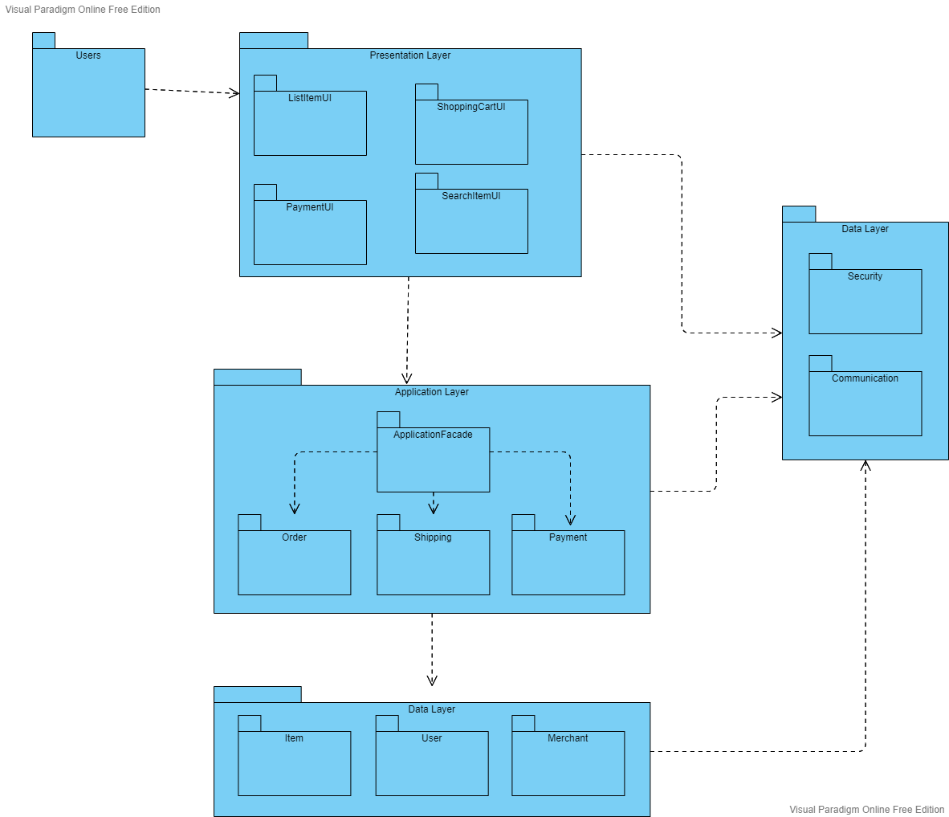

Component Diagram

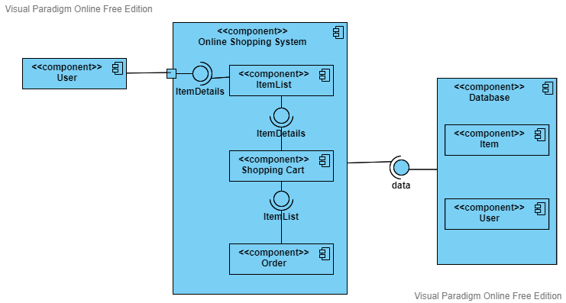

Deployment Diagram

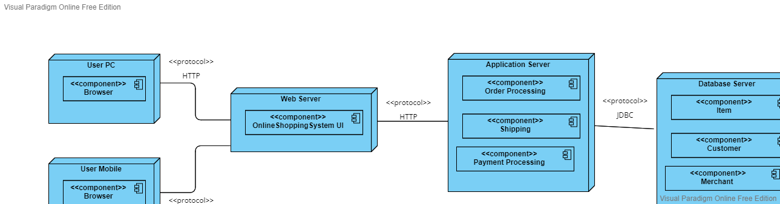

This online shopping system uses 3-tier architecture which consists of presentation layer, application layer and database layer. Each tier runs on its own architecture. Besides, each tier can be developed by different development team at the same time. Update made on one tier does not affect other tiers, which separation of concern exists and improve modifiability.